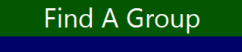

User Guide

© The Workers, Benjamin Deleuze, Thomas Matragrano, Ariana, Moonslave 12/2019

Table of Contents

Introduction 1

Getting Started 1

System Requirements 1

Quick Start 1

Software Usage 1

Registration 1

Login 1

Member Home 1

Staff Home 1

Glossary 1

# Introduction

Extracurricular activities are a great way to meet new people and find interest in new subjects. With so many clubs, games, and events on every high school campus, meeting locations, times, and information can be hard to find and coordinate. Using the FindaGroup application, these schools can better facilitate the fluctuation of meeting details by editing this information. Students can then view this and will be more informed on future events.

Click to insert software name allows you to:

* Register a User
* Join Groups as a Student or Staff Member
* Create and Update Groups as Staff
* Create and Accept Roles as Staff
* Request a Role as a Student

The FindaGroup Application is accessible using the Java interface “IntelliJ”. This is because of our limited knowledge of other languages and the interface’s usage in our schooling.

# Getting Started

## System Requirements

Windows 8.x (Desktop) or above

## Quick Start

**Registration**



**Join a Group**



**Request a Role as Student**



**Create a Group as Staff**



**Update Meeting Information**



**Accept Role Requests**



**Create Roles to be Requested**



# Software Usage

## Registration

1. Registration

At the login screen, click the button labeled “Register” to enter the registration page.

Enter your information

School ID: Enter your Student Identification Number for this field (required).

PIN: Create a 4-digit password that will be used to login (required).

Graduation Date (If Known): Enter your scheduled graduation date, if known. Enter this date in the format (i.e. Date = MM/DD/YYYY i.e. “12/02/2015”)

STAFF ONLY

If you are registering as a staff member, leave this field empty.

Check the box indicating that you are a part of the staff.

Click the button labeled “Register” to complete your registration.

Click the button labeled “Exit” to return to the login screen.  
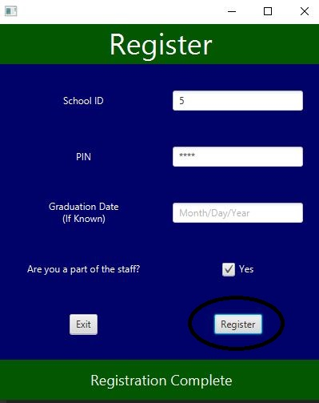

## Login

1. Login

If you do not have an account, click the button labeled “Register” to go to the registration page. Follow the instructions under “Registration” in this guide to register your account.

After successfully creating an account, enter your School ID and PIN that you used to make the account.

Click the button labeled “Login” to login.

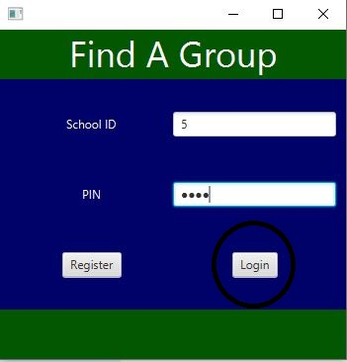

## Member Home

1. Join Group as Student

Groups can be joined as both a Staff Member and a Student Member.

* Under the “Join Group” tab, a list of groups that you have not yet joined will be displayed.
* To join a group, first select the group under the “Select Group” label. You can then view the meeting times, places, and group roles that have currently been published.
* If you would like to join the group, click the “Join Group” button.

This group will now be viewable under the “Current Groups” tab, which displays all the groups you have joined.

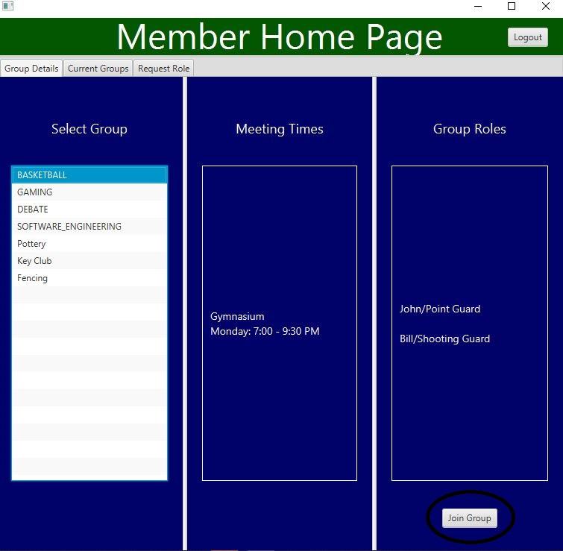

1. Request Role as Student

Students can request roles for groups that they are currently in.

* Under the “Request Role” tab, a list of your current groups will be displayed to the left.
* Selecting a group will display any available roles in that group.
* To request a role, select the role that you want to request.
* Under the label “Enter Requesters Name”, enter your name in the field.

To complete your request, click the button labeled “Request Group Role”.

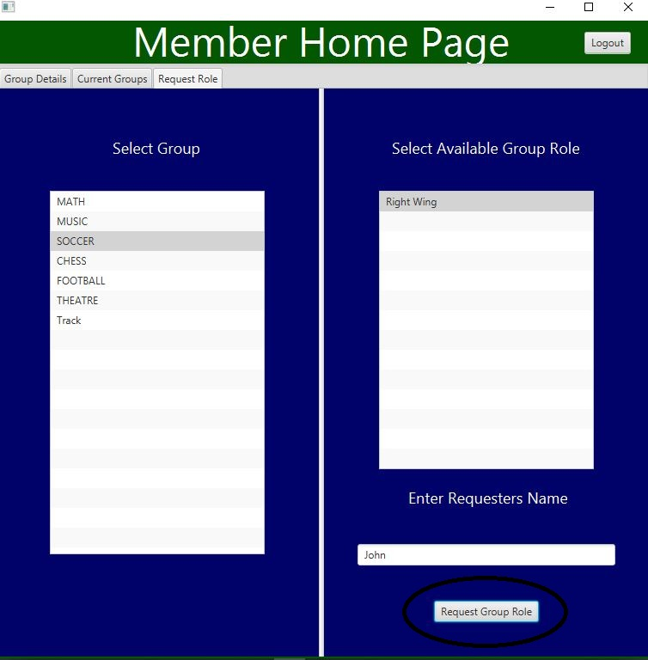

## Staff Home

1. Join Groups as Staff

Groups can be joined as both a Staff Member and a Student Member.

* Under the “Join Group” tab, a list of groups that you have not yet joined will be displayed.
* To join a group, first select the group under the “Select Group” label. You can then view the meeting times, places, and group roles that have currently been published.
* If you would like to join the group, click the “Join Group” button.

This group will now be viewable under the “Group Details” tab, which displays all the groups you have joined.

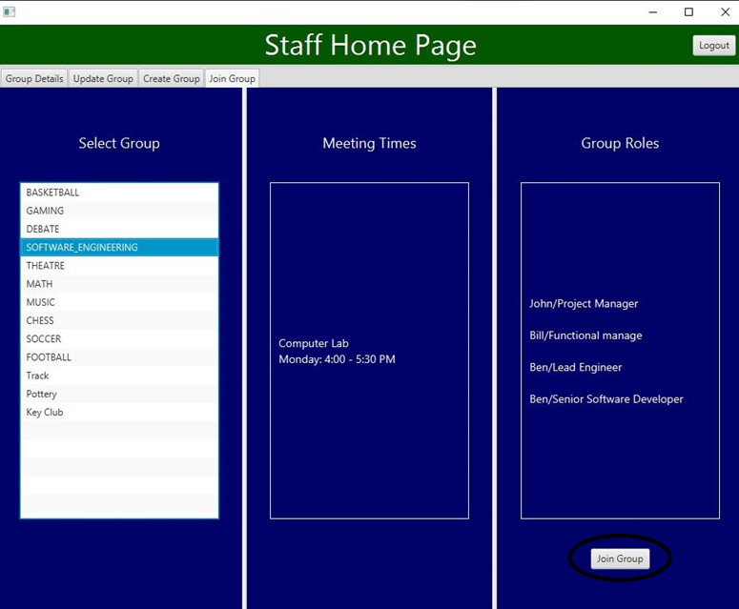

1. Update Groups as Staff

As a staff member, you can update current meeting information or clear it completely.

* Under the “Update Group” tab, a list of your current groups will be displayed on the left.
* Select the group in which you want to edit.
* In the middle of the page, under “Update Meeting Times”, enter the time for the new meeting in the format: (Time = Day T:TT – T:TT (AM or PM) i.e. Monday 5:00 – 7:30 PM)
* Under “Update Meeting Place”, enter the location in which the meeting will take place.
* Each time and place will be respectively coordinated by its placement on the Update Groups tab.
* Click the button labeled “add to meeting info” to add this information to the current meetings of that group.

If you wish to clear ALL meeting information (time and place), click the button labeled “Reset Meeting Info”.

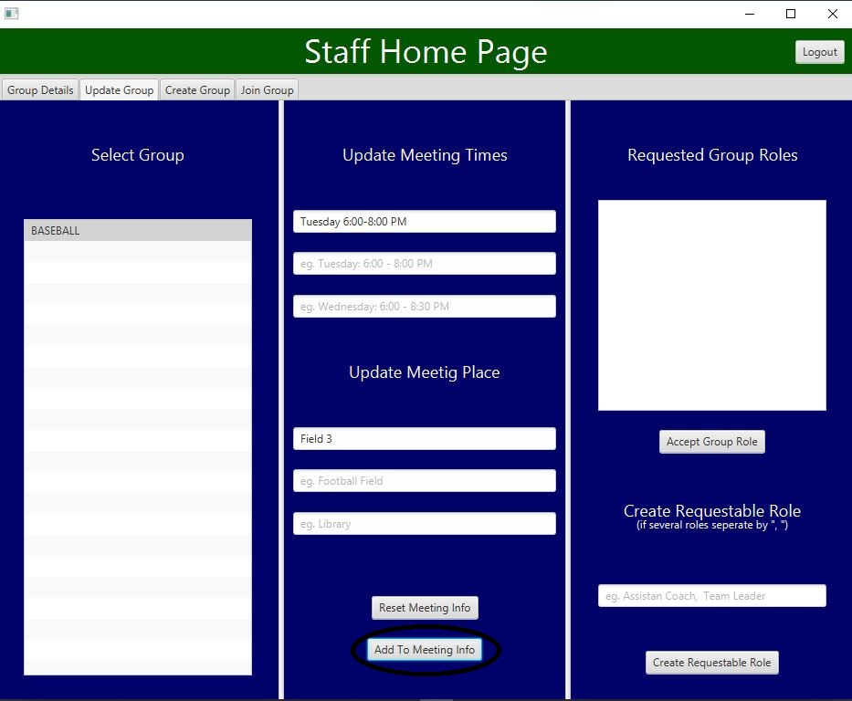

1. Accept Roles as Staff

As a Staff member, you can accept roles that are requested by Students.

* Under the “Update Group” tab, a list of your current groups will be displayed to the left.
* Select the group in which you want to accept a role for.
* On the panel to the right, under “Requested Group Roles”, students’ Name and Requested Role will be displayed in a list.
* Select the role in which you want to accept.
* To accept this role request, click the button labeled “Accept Group Role”.

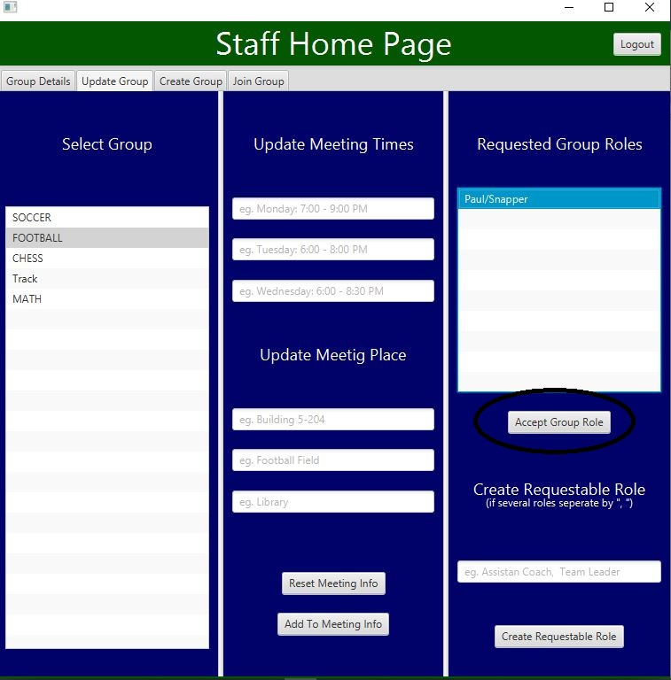

1. Create Roles as Staff

As a Staff member, you can create roles that Students can request for.

* Under the “Update Group” tab, select which group you would like to create the role for under the list of your current groups.
* On the panel on the right, under “Create Requestable Role”, enter the role you would like to create for that group.
* If adding multiple roles, separate them with a “,”. i.e. “Captain,Player”.
* Once you are satisfied with the roles you want to create, click the button labeled “Create Requestable Role” to create the roles.

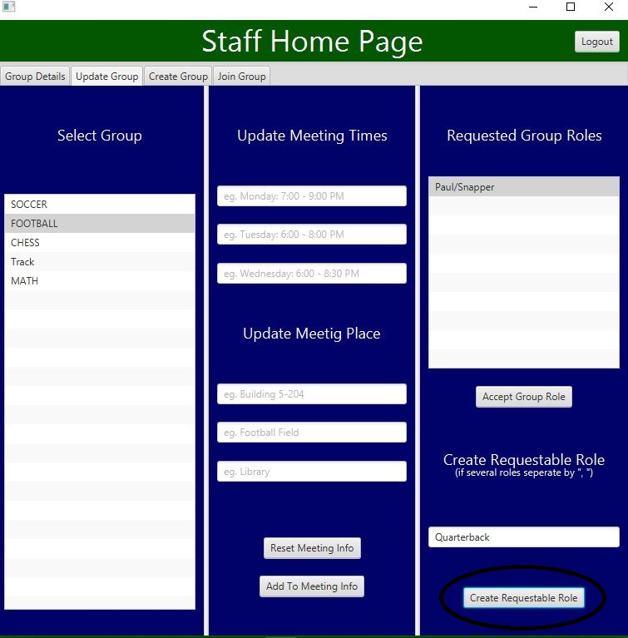

1. Create New Group as Staff

As a staff member, you can create new groups to be joined.

Under the “Create Group” tab, there will be multiple fields:

* *Group Name*: Enter the name of the group you wish to create.
* *Set Meeting Times:* Enter the time in which a meeting will take place in the format (Time = Day T:TT – T:TT (AM or PM) i.e. Monday 5:00 – 7:30 PM)
* *Set Meeting Place:* Enter the location in which the corresponding time is set for. You can set up to three meetings, where each row of Time and Place is one meeting.
* *Create Requestable Role:* Enter a possible role for the group. If you wish to add multiple roles, separate them with a “,”. i.e. “Captain,Player”.

Once you have completed the fields above, click the button labeled “Create Group”.

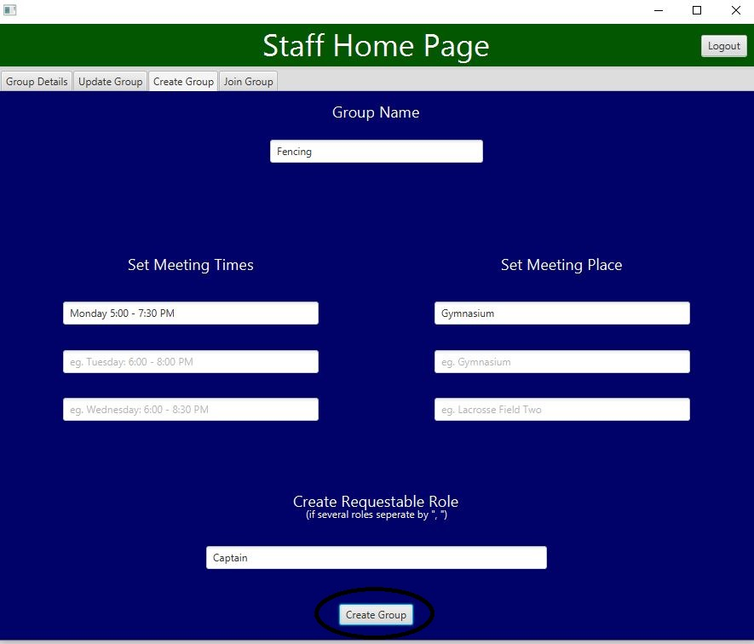

# Glossary

Click or tap here to enter term.

Click or tap here to enter term definition.